

**Beyond Curriculum Experiment Submission for Advance Learner**

Experiment - Small Office Home Office/SOHO Network Design & Implementation

(Kunsh Sabharwal – 01117711623 – B.Tech AI-ML(A)-4TH SEMESTER)

**Aim: -** Small Office Home Office/SOHO Network Design & Implementation

**Objective: -** To create small office home office (SOHO) network design with VLAN connectivity and devices like Router, Switch, PC’s, Printers and Access Points in Cisco Packet Tracer.

**Theory: -** A Small Office Home Office (SOHO) network is a compact, cost-effective setup designed for limited users and devices. In this experiment, Cisco Packet Tracer is used to simulate a SOHO network with routers, switches, PCs, printers, and access points. VLANs (Virtual Local Area Networks) allow you to divide one physical network (like a switch) into multiple isolated networks. Devices in different VLANs cannot communicate directly, even if they’re connected to the same switch—unless allowed via a router or Layer 3 switch giving VLANs advantages like: - Improved Security, Better Performance, Flexibility and Simplified Management. In this experiment VLANs are configured to logically separate departments or functions, enhancing security and traffic management. This setup enables efficient communication of devices both wired and wirelessly, device sharing, and internet access across the network.

**Procedure: -**

1. Start by creating 3 main sectors in which we will be implementing VLANs. Name them as ADMIN/IT, FINANCE/HR and CS(Customer Service)/RECEPTION.
2. 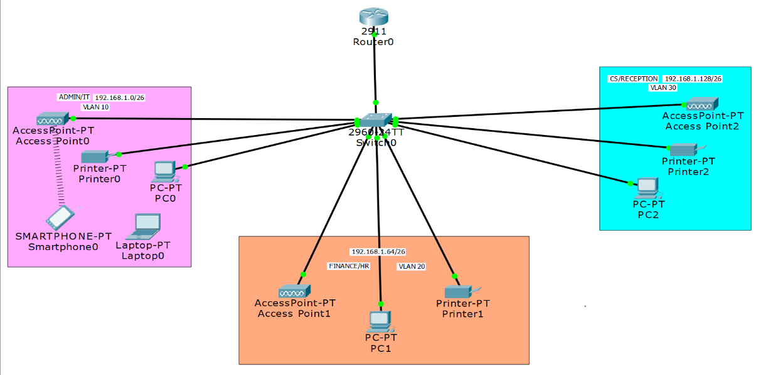Arrange the PC’s, Printers and Access Points of each sector as shown in the topology below and connect them to a switch and router.
3. Once the above topology is created, we start by assigning names to VLANs of each sector as VLAN10, VLAN20 & VLAN30.

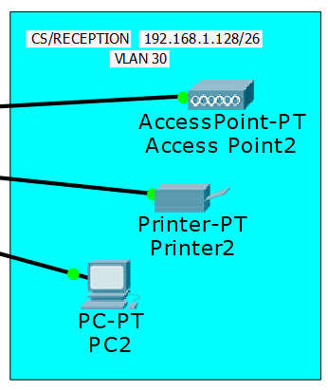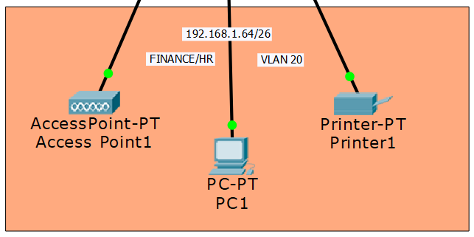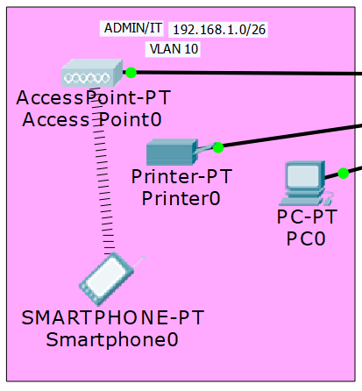

1. Now since we have 3 subnets

along with base network being 192.168.1.0

Therefore, we have: - Class C generic Subnet Mask = 255.255.255.0

= 11111111. 11111111. 11111111.00000000

Hence on borrowing 2 bits (as no. of subnets = 2^n=3, making n=2 (approx.))

New subnet mask = 11111111. 11111111. 11111111.11000000

= 255.255.255.192

Also block size = 64.

Hence, we get: -

1. 1st Subnet –
   1. Network ID – 192.168.1.0
   2. Broadcast ID – 192.168.1.63
   3. Host Range – 192.168.1.1 to 192.168.1.62
2. 2nd Subnet –
   1. Network ID – 192.168.1.64
   2. Broadcast ID – 192.168.1.127
   3. Host Range – 192.168.1.65 to 192.168.1.126
3. 3rd Subnet –
   1. Network ID – 192.168.1.128
   2. Broadcast ID – 192.168.1.191
   3. Host Range – 192.168.1.129 to 192.168.1.190

Now we assign 192.168.1.0/26 to VLAN 10, 192.168.1.64/26 to VLAN 20 and 192.168.1.128/26 to VLAN 30.

1. Now in the switch, in CLI, run the below commands: -
   1. En
   2. Conf t
   3. Int range fa0/2-4
   4. Switchport mode access
   5. Switchport access vlan 10

Repeat the above commands for VLAN 20 and 30 with fa0/5-7 and fa0/8-10 respectively.

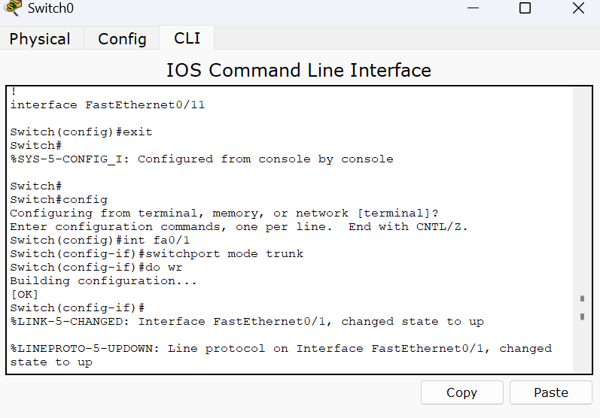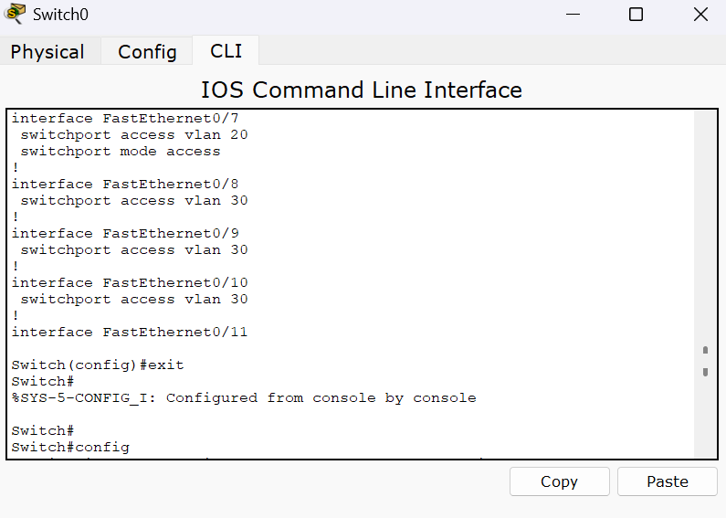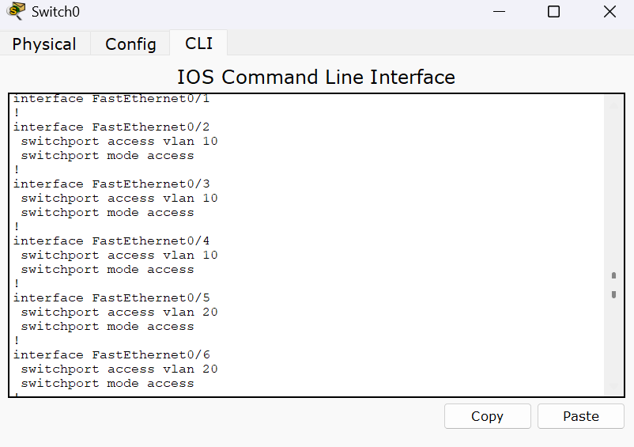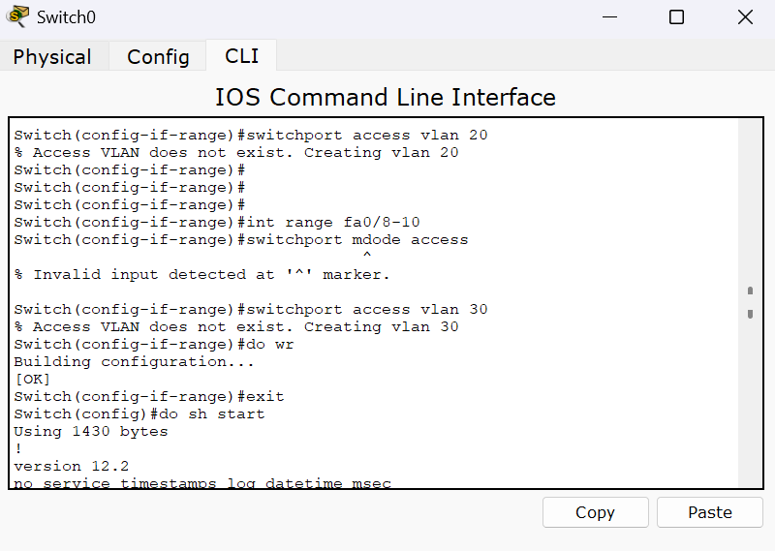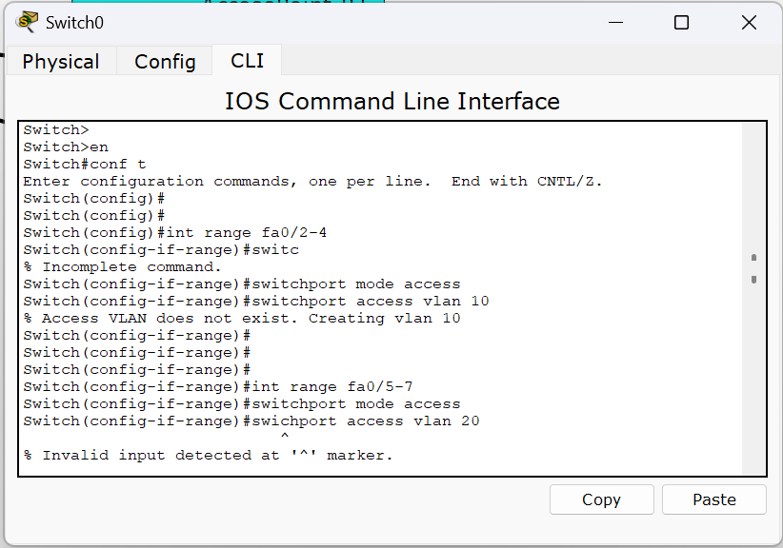

1. 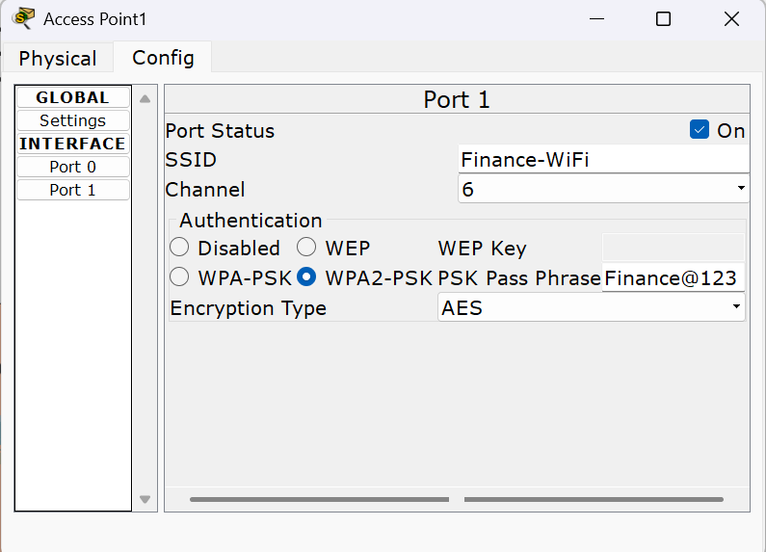Now we may configure access points of each sector one by one by going to the config tab in the access point device and in port 1, assign respective port status, switch authentication to WPA2 – PSK and set up appropriate password.
2. 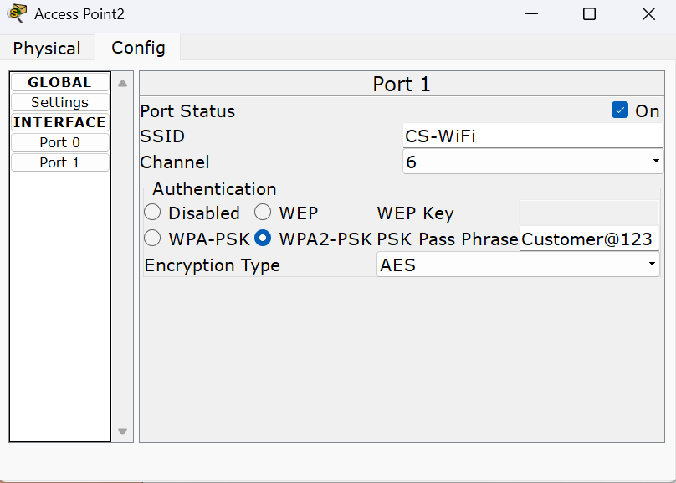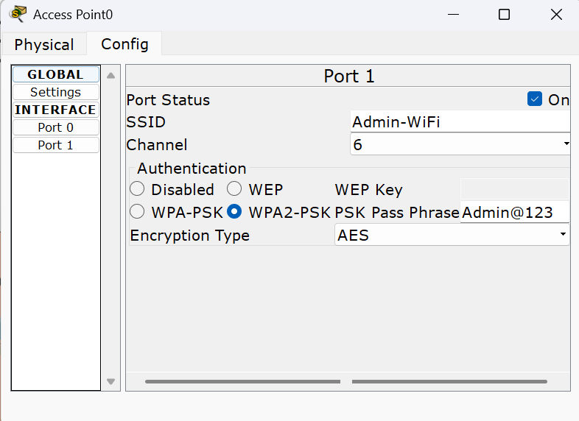Again, in the switch run the below commands: -
   1. int fa0/1
   2. switchport mode trunk
   3. do wr
3. Now we move to the routers commands under the CLI tab. Execute: -
   1. En
   2. Config t
   3. Int gig 0/0
   4. No sh
   5. Do wr
   6. Exit
   7. Int gig0/0.10
   8. Encapsulation dot1Q 10
   9. Ip address 192.168.1.1 255.255.255.192
   10. Exit

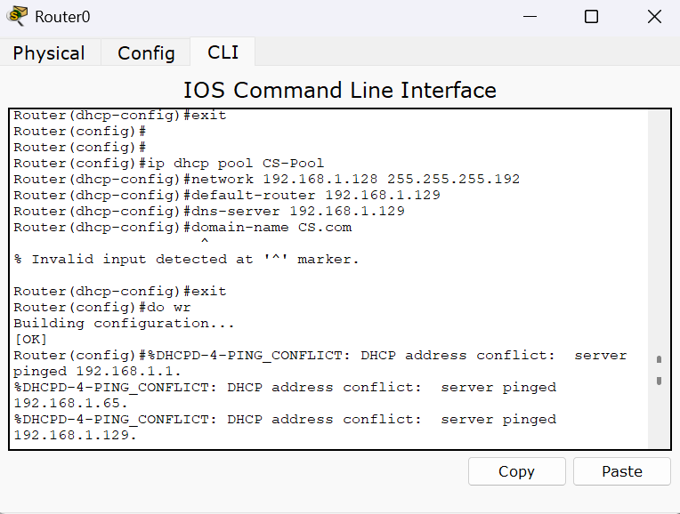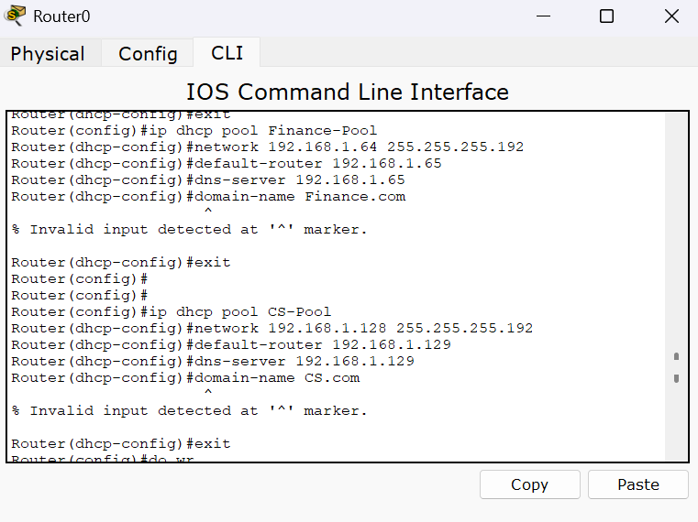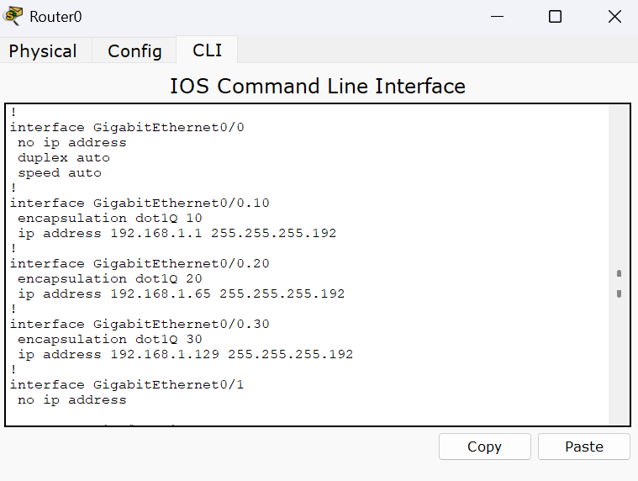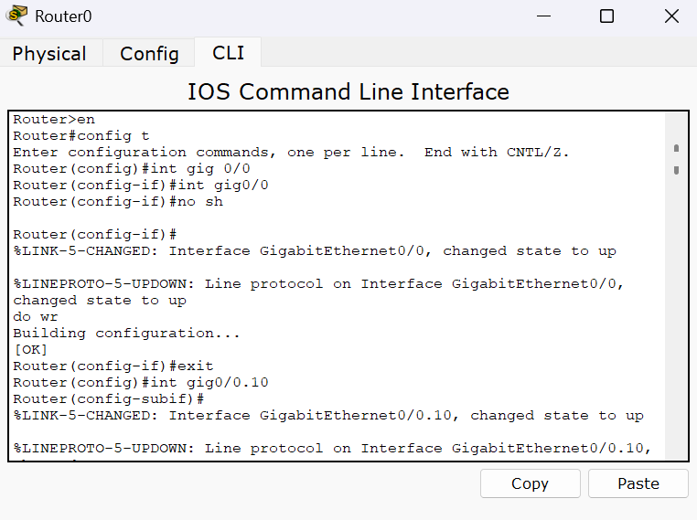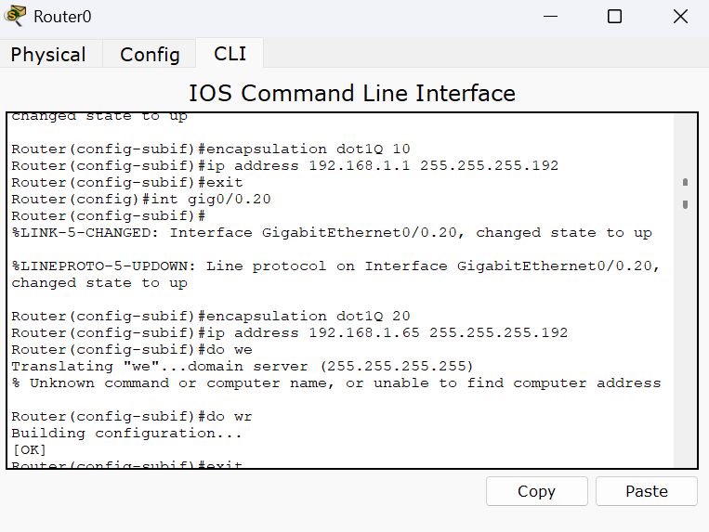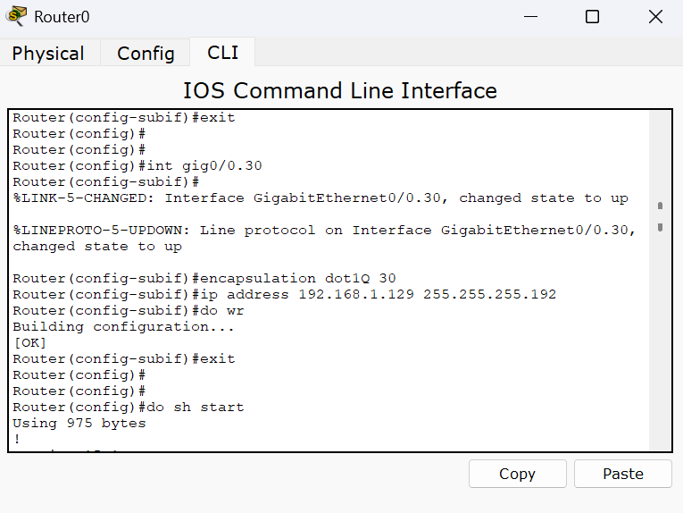Run the commands from (g) to (j) again each time changing the vlan number (int gig0/0.20 and int gig0/0.30 with encapsulation dot1Q 20 and encapsulation dot1Q 30) and their respective ip address (beginning host range) as discussed in step 4.

1. Also enable DHCP by executing below commands in routers CLI –
   1. Service dhcp
   2. Ip dhcp pool Admin-Pool
   3. Network 192.168.1.0 255.255.255.192
   4. Default router 192.168.1.1
   5. Dns-server 192.168.1.1
   6. Domain name Admin.com
   7. Exit

This command automatically assigns IP addresses to each device of VLAN 10 (ADMIN/IT). Repeating the steps, create Finance-Pool and CS-Pool with respective VLANs & default router, dns-server (beginning host range) from step 4.

1. 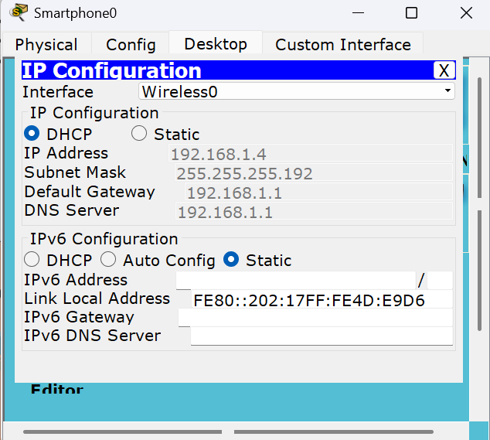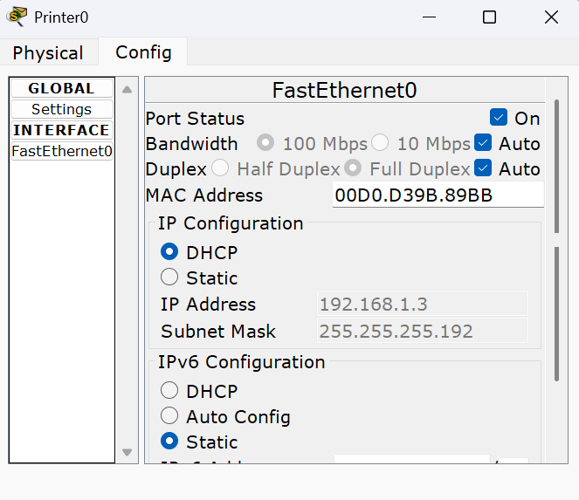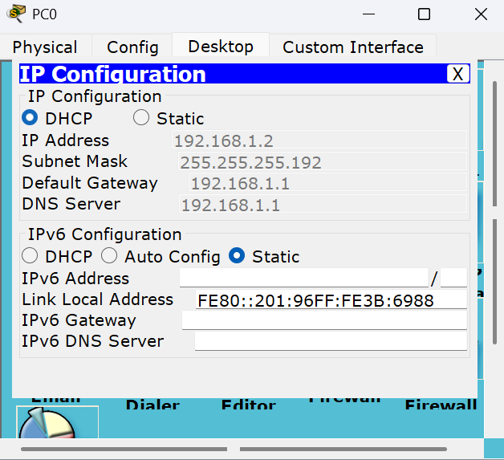 Now if we visit every device of each sector and switch them to DHCP in desktop->IP configuration(for PCs) and Fast Ethernet 0/0(for printers) we can see they automatically get assigned the IPs.
2. 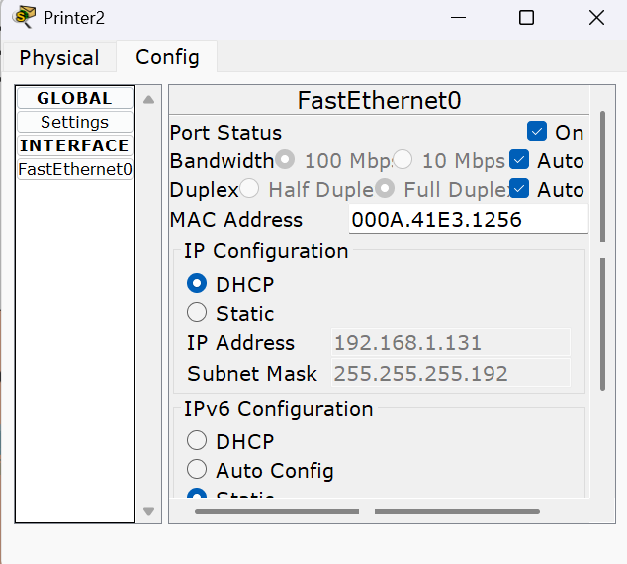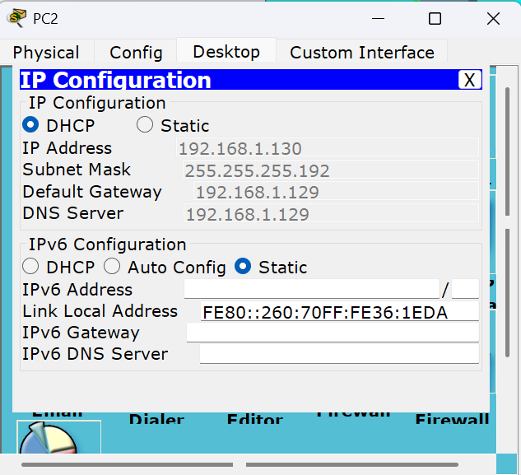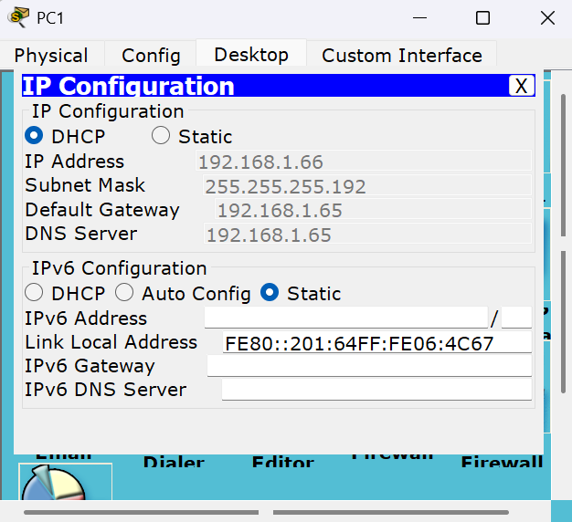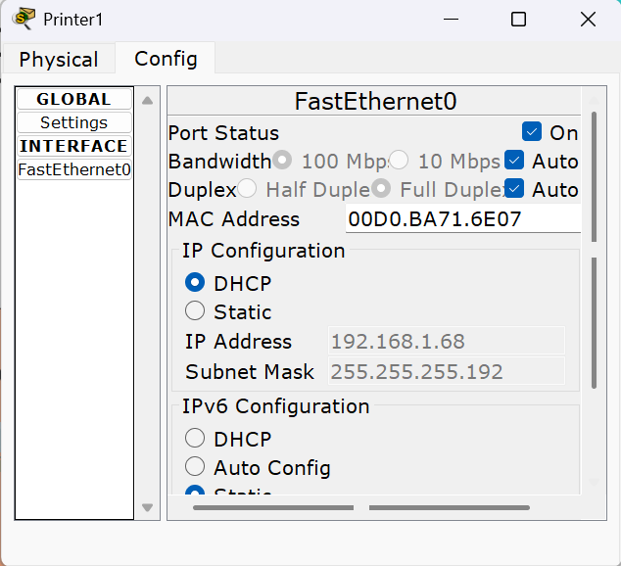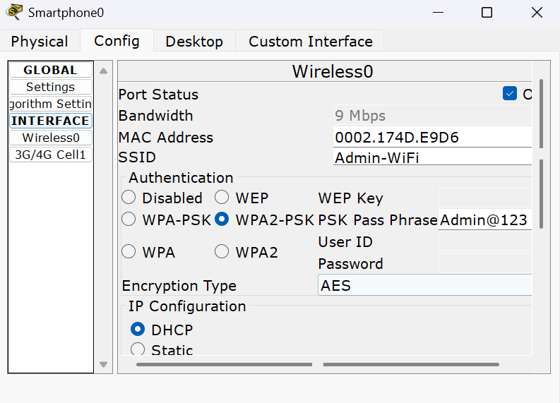 In sector 1/VLAN10, we have also connected a wireless device (Smartphone) to demonstrate wireless connections. To connect we execute: -
   1. Go to config->Wireless0
   2. Enter SSID as Admin-WiFi and authentication WPA2 – PSK with password Admin@123.

We may also see the IP address given to this smartphone in IP Configuration.

12) In order to check working of connections we may ping one device from the other (let’s say smartphone in sector 1 to printer in sector 3).

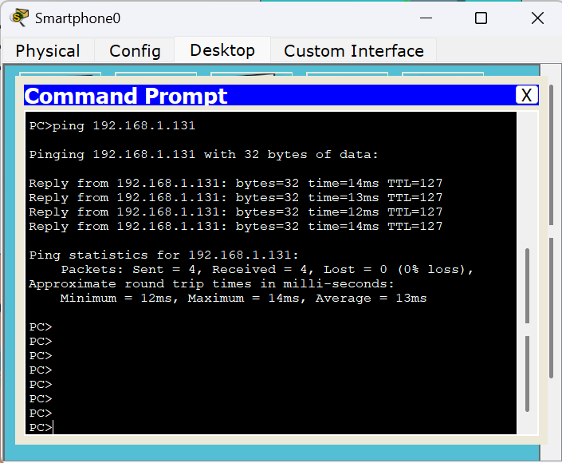

**Conclusion: -** Through this experiment we understood how VLANs work and communicate with each other and how IP Addresses are assigned using DHCP service along with the topology that can be created in order to implement a Small Office Home Office/SOHO Network Design.

**Result: -** I learnt how to implement VLAN in Cisco Packet Tracer to make multiple VLANs communicate both wired and wirelessly in a small office home office (SOHO) network design.